**CRUCEROS ON SALE FUNCTION REQUIERMENTS**

The site must be conected all the time with the original site in order to get Access to de cruises database.

Sign in is requiered for the user. The user must be logged in for our website to show him the search results.

Initial subscription is requiered. The data recollected in the subscription form is for our website database only.

The data recollected in the “Contact Us Today” form is for our website database only.

If the user maker a search without being signed, the site requieres him to sign-in or register. The site wont display any search results if the user isnt logged. The user´s search data must be kept to show the result after the sign up.

Se necesita un backend. Debe contar con creación de perfiles, administrador y roles de manejo.

El backend permitirá ver la base de datos de usuarios registrados en el sitio, los pedidos de estos, enviar notificaciones a los vendedores para que gestionen los pedidos.

A backend is needed. Must have creation of profiles, administrator and management roles.

The backend will allow to see the database of registered users in the site, the orders of these, send notifications to the sellers so that they manage the orders.

Items de Modulos en Back-end

1. Creación de perfiles /profile /roles creation
2. Notification system for the salesperson
3. Users database acce s
4. Administrador de contenido para las Página / Content manager for the Page
5. Notificaciones a los vendedores
6. Listado de clientes que se suscribieron a los boletines
7. Precio (procentaje de utilidad)

Items of Modules in Back-end

1. Creating profiles / profile / roles creation
2. Notification system for the salesperson
3. Users database access
4. Content Manager for the Page / Content manager for the Page
5. Notifications to sellers
6. List of clients who subscribed to the newsletters
7. Price (profit percentage)

**SITE USERS (BUYERS)**

* 1. User Registration Process:

The user must register by filling in the form

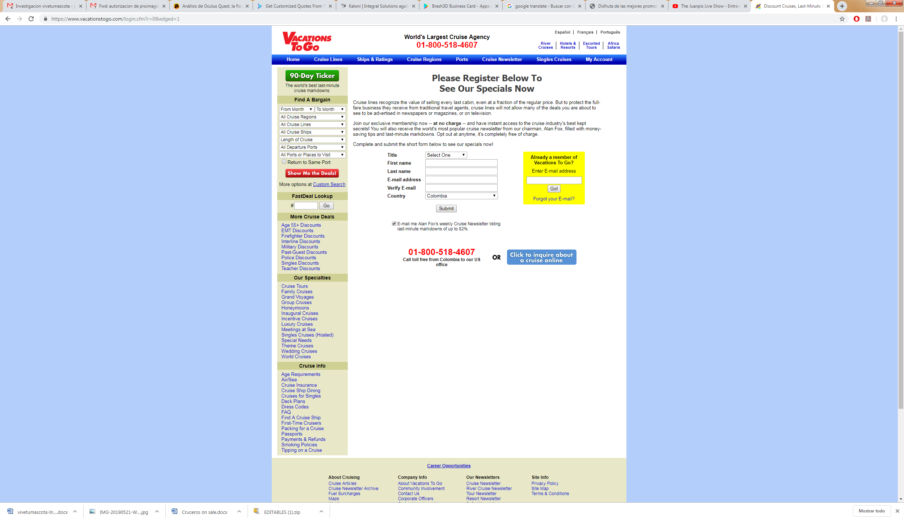

This database is created for our site.

1. The registered user is the only one who can see and / or consult the promotions. To consult it you must enter with the email that you entered in the registry

1. If the user makes a query without having logged in, the site must ask to do so, and save the query. Do it once the registration is finished.

2. The queries of our site to the database of the cruises page must be generated by means of a predetermined user that will always be the same. (crucerosonsale@gmail.com)

3. All purchase information must be sent by registered mail by the user. Information generated by our site

4. The user can leave the newsletter at any time

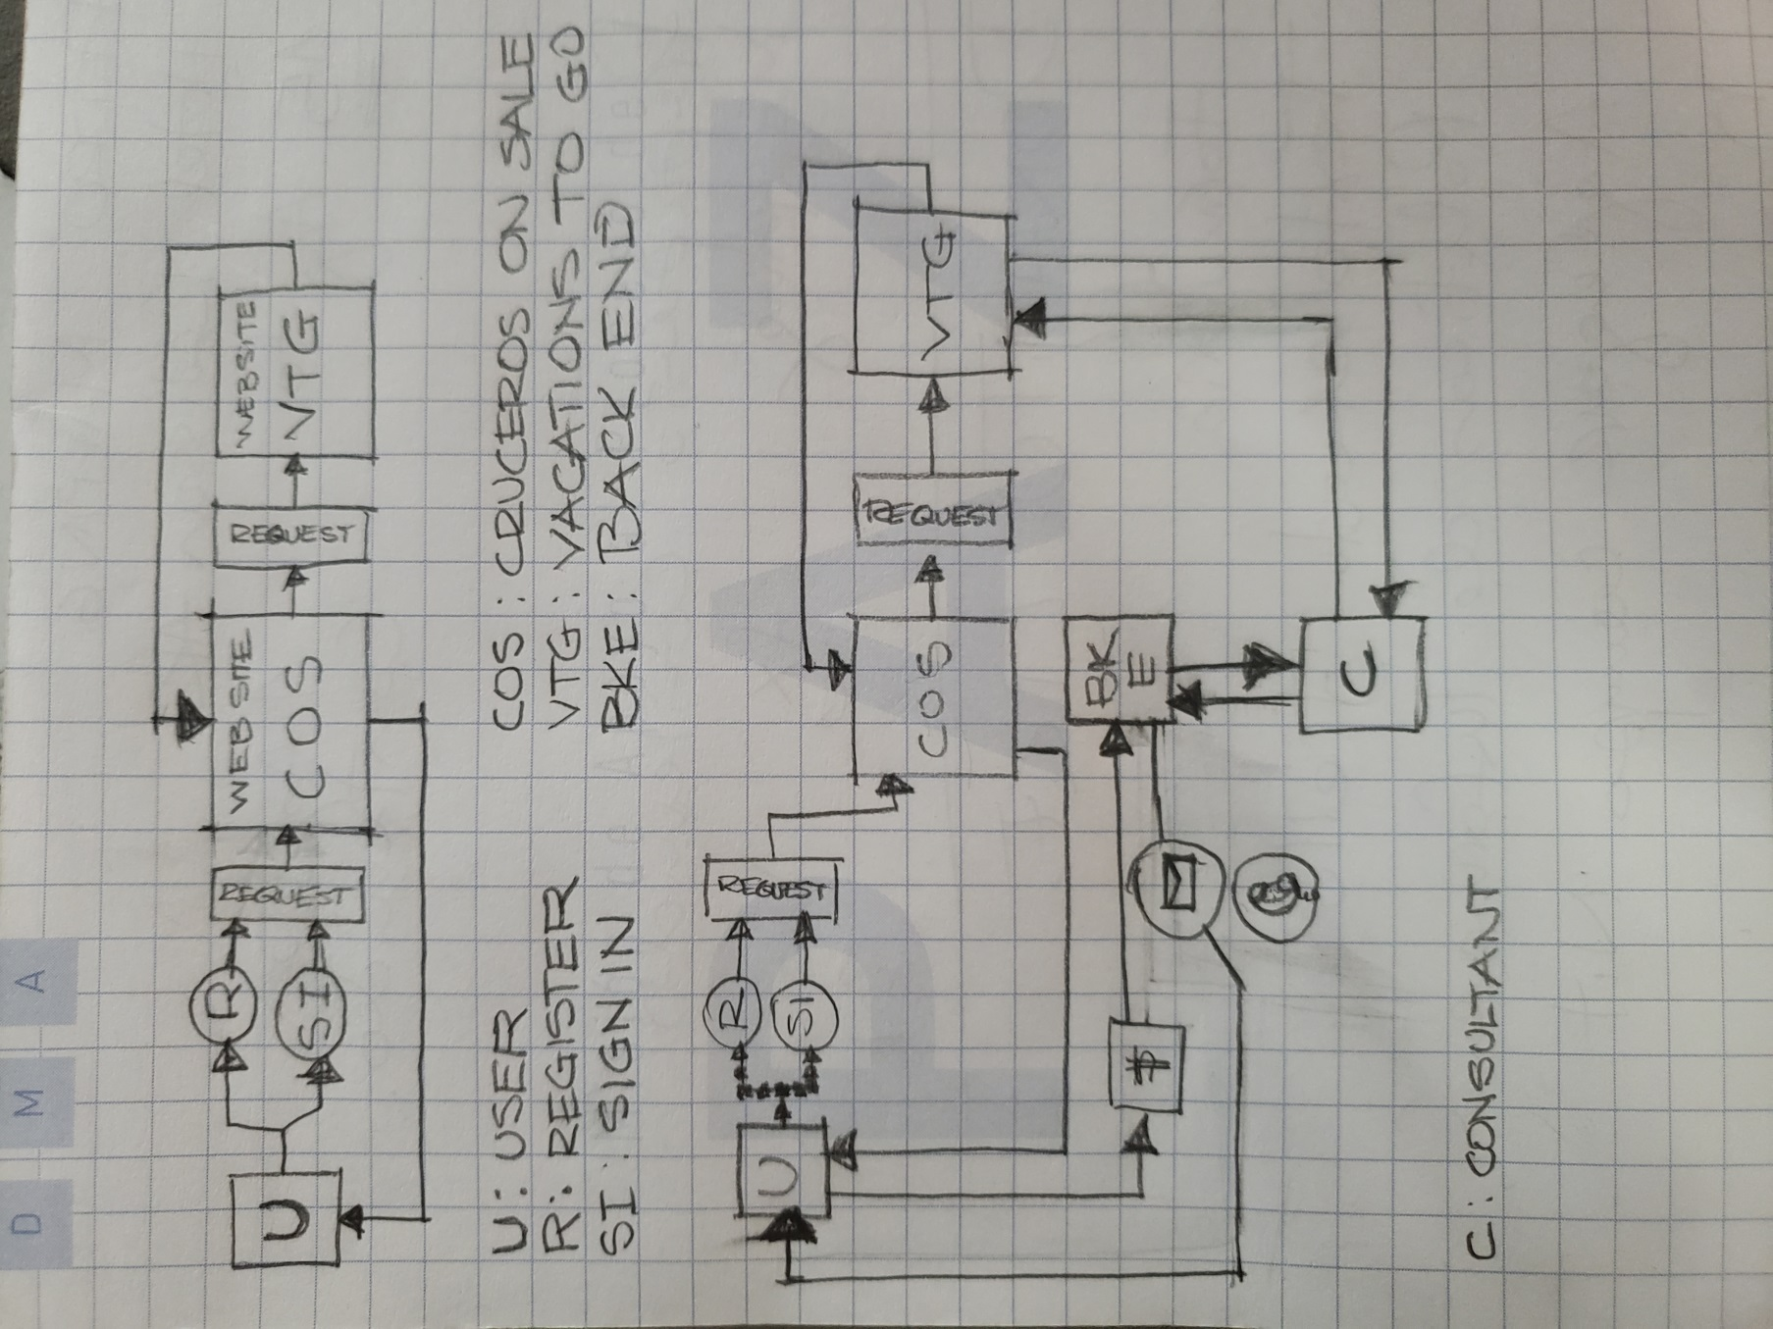

**BACKEND USERS (ADMINISTRATORS AND CONSULTANTS)**1. Internally, the "super administrator" of the backend, determines the utility of sale of the packages.

2. You must create a backend that allows you to view the entire database of registered users. Notify the users who are making purchases and assign them to an advisor.

3. The advisor will be the person in charge of carrying out the purchase process with the portal "vacationstogo.com"

4. The advisors must be created from the backend. Name, surname, address, telephone number, username, city, country, email.

5. The backend must send notifications of purchase orders, so that they can process the purchase.

6. Once the purchase is made, the backend must generate a PDF with the information of the purchased product, the reservation number or code, description of the product, chosen itinerary, dates of departure, purchase summary. The document must be generated with the company's letterheads.

7. The PDF is created from the information sent by the portal "vacationstogo.com", the backend must have a module that allows creating the pdf mentioned in number 8. It must have the same information fields as the file original.

8. User's purchase history. Account details of the client. Payment method information. Registration of card for payments.

9. Connection to payment gateways.

10. (super administrator) REPORTS OF THE CONSULTANTS. Purchases assigned, purchases on hold, purchases in progress, purchases completed. Save histories.

11. Relate purchases with consultants.

12. The Super Administrator controls the access permissions of the other profiles to the modules of the site.

13. The database of users should be able to export in orderly Excel format.

14. It should be possible to include the check-in confirmation links of the cruise ships.

15. Analyze the information format that Vacationstogo provides in order to generate the best option to create the information format that should be generated from that information.

16. Sales report, Earnings. Payments

17. Reports by Cruise Line, destinations, dates

18. The backend must allow the administration of the contents of the site

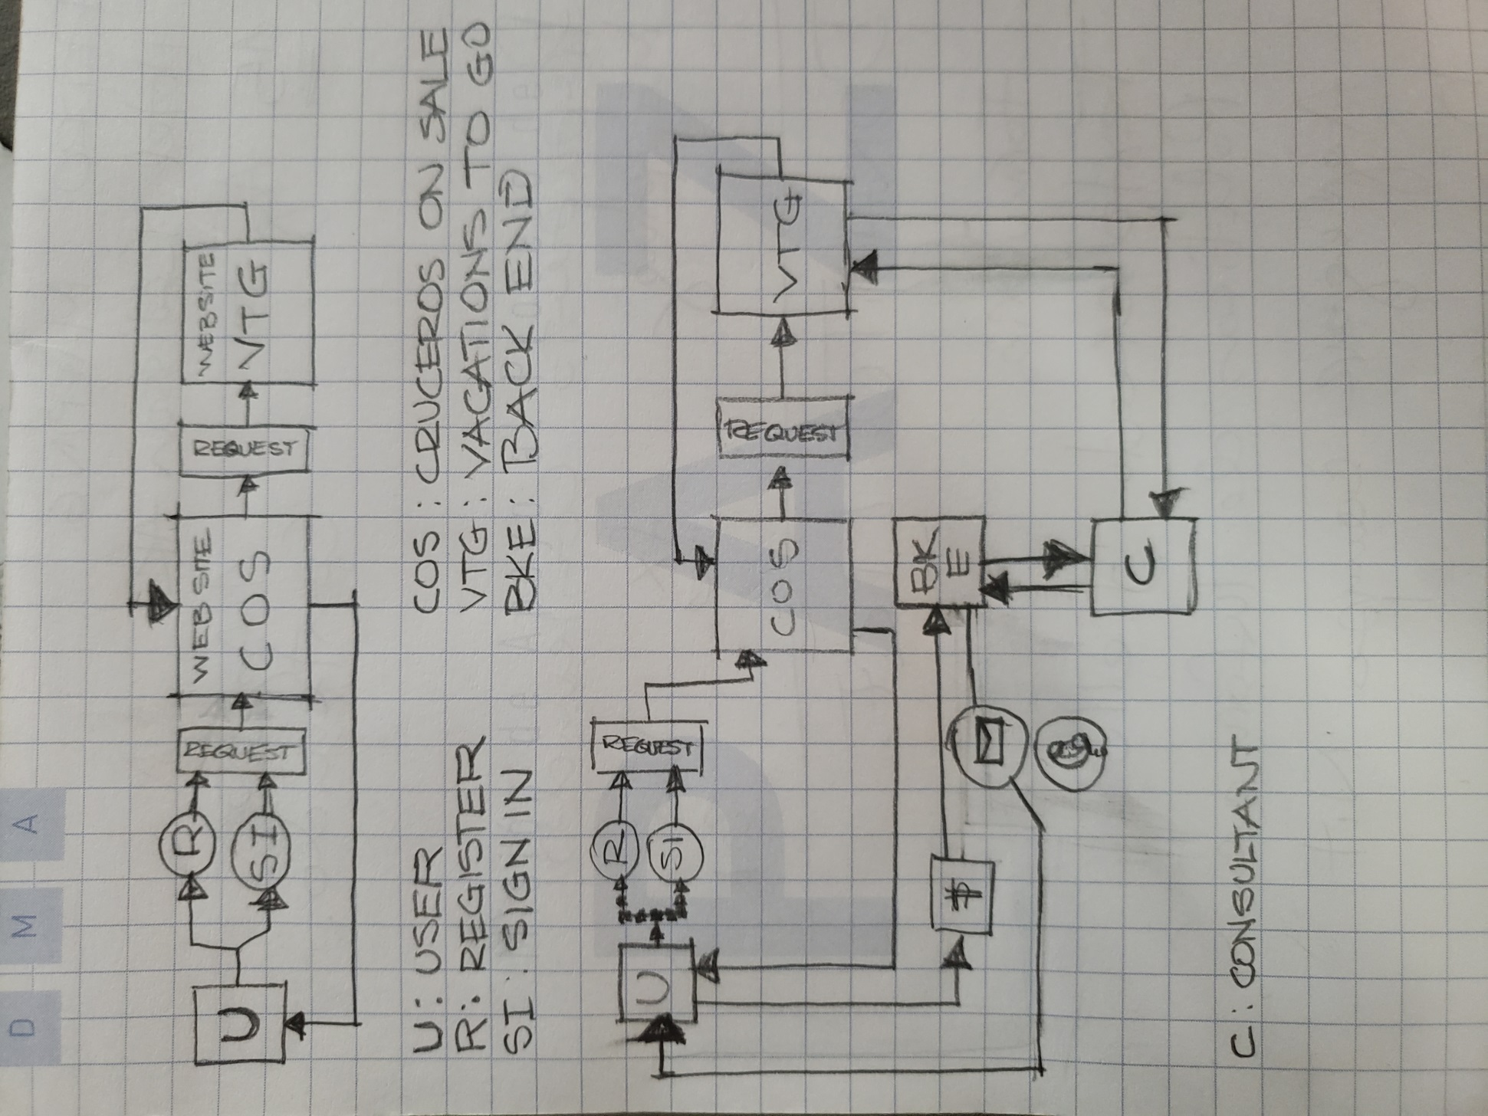

The user must be registered to request information in the website. The request is processed by Cruceros On Sale (COS), COS makes the same request to Vacations To Go (VTG) and VTG sends back the information to COS and COS displays it to the user.

The information request between COS and VTG is made using [crucerosonsale@gmail.com](mailto:crucerosonsale@gmail.com) as the registered user making the request to VTG.

With the scraped information, the site must have check boxes for the user to choose the desired plan. Number of travellers, adults, kids, etcétera. The user press the BUY option, Then the website will give a message telling the user that a Quote with the selectect packages and options will be sent to his e-mail during the next 12 hours.

Meanwhile the backend will send that information selected by the user for the counselor to make the proper quote.

The backend must have a quote editor for the counselor to input all the information from Vacations to Go. (See reference image). Once finished, This form will be send to the client, the structure will be as the image bellow,

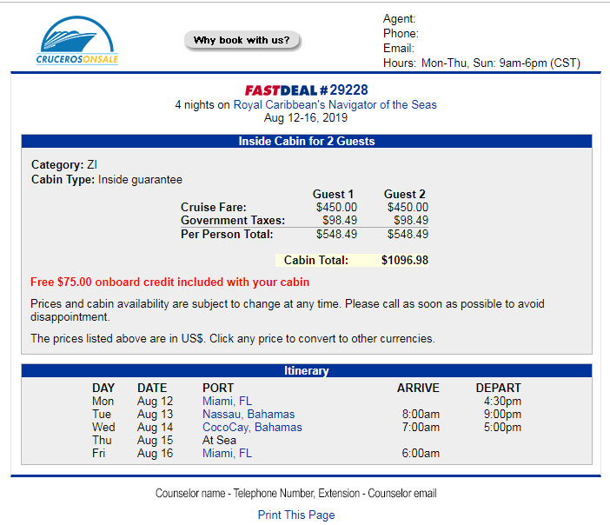

This quote must display our inscreased prices according to the gain percentage previously determinated into the platform

The form will also contain a payment link for the client to make the purchase. The form will be branded with the CrucerosOnSale logo.

Once the payment has been made, And all the information corfirmed, the counselor using the sytem will send the following:

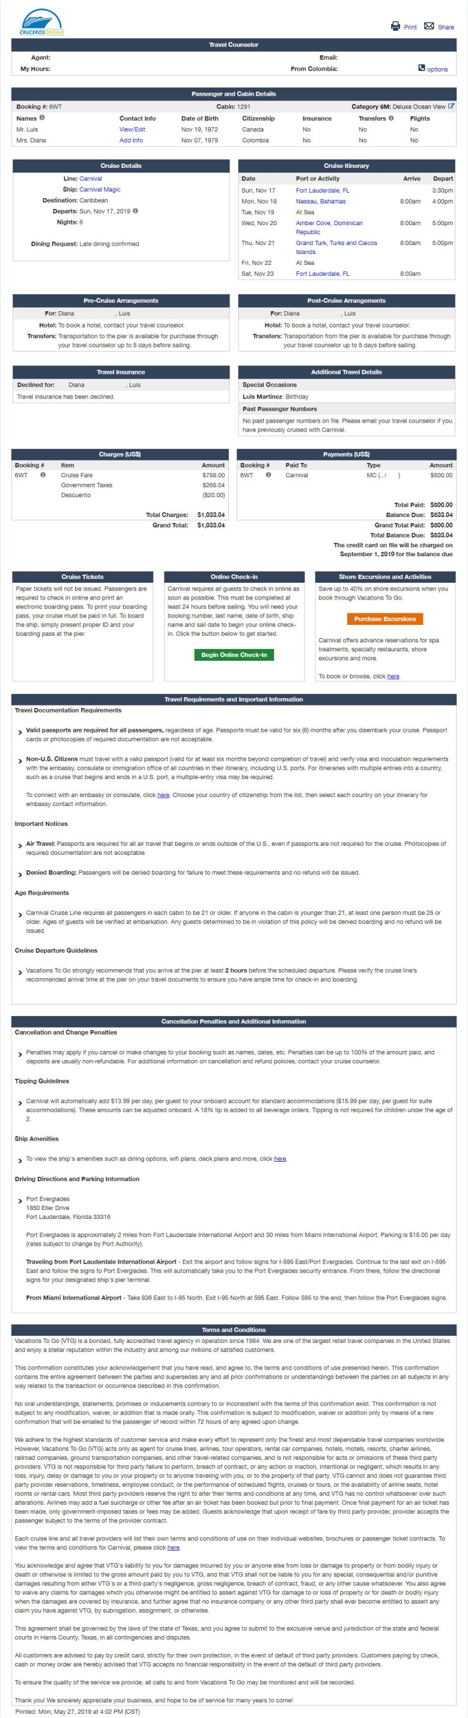

The backend must have the tools necessary to create such format. It will also have the capability to create buttons links to external websites. (For example: Checkin process for each cruiser line or especific line recommendations). The client will recieve an email with a generic text giving him thanks for the purchase. If the client want to access this information, there will be a link that will allow him to see this imformation.

The backend will be capable of managing all the sections of the main site.

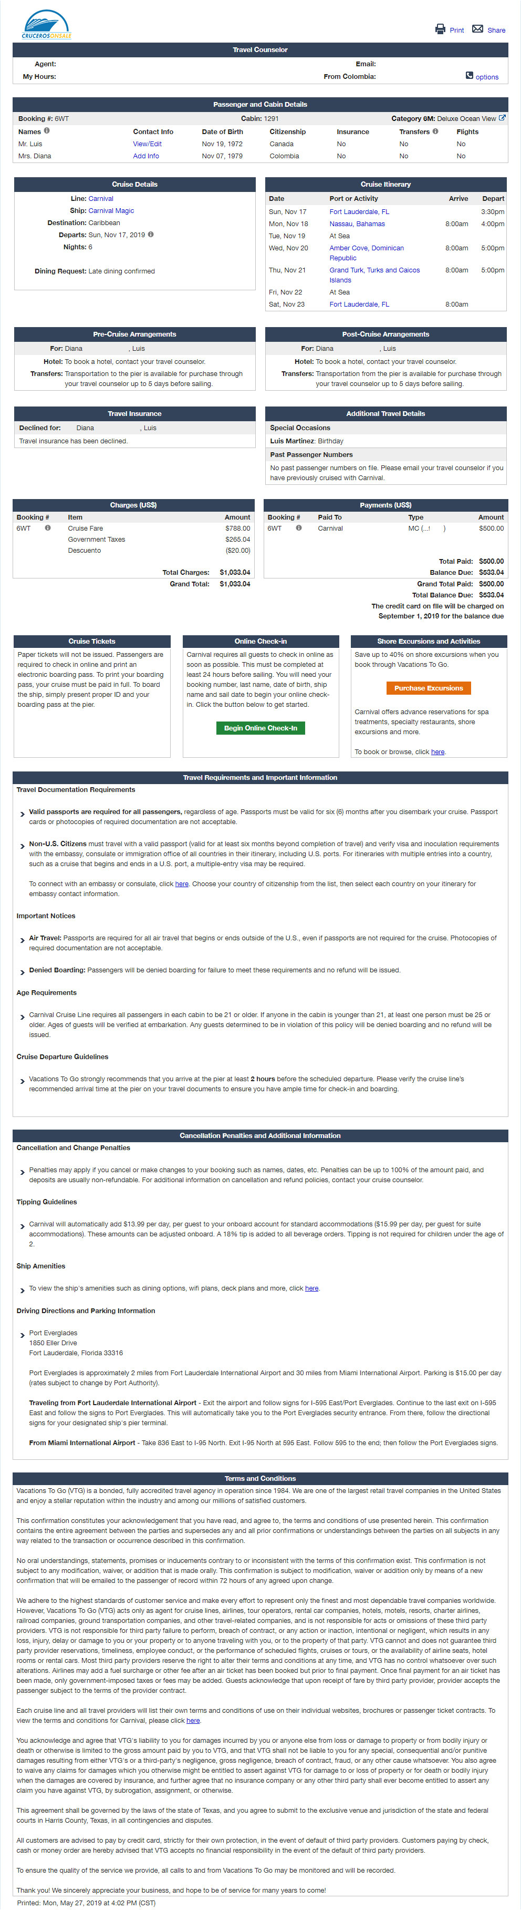

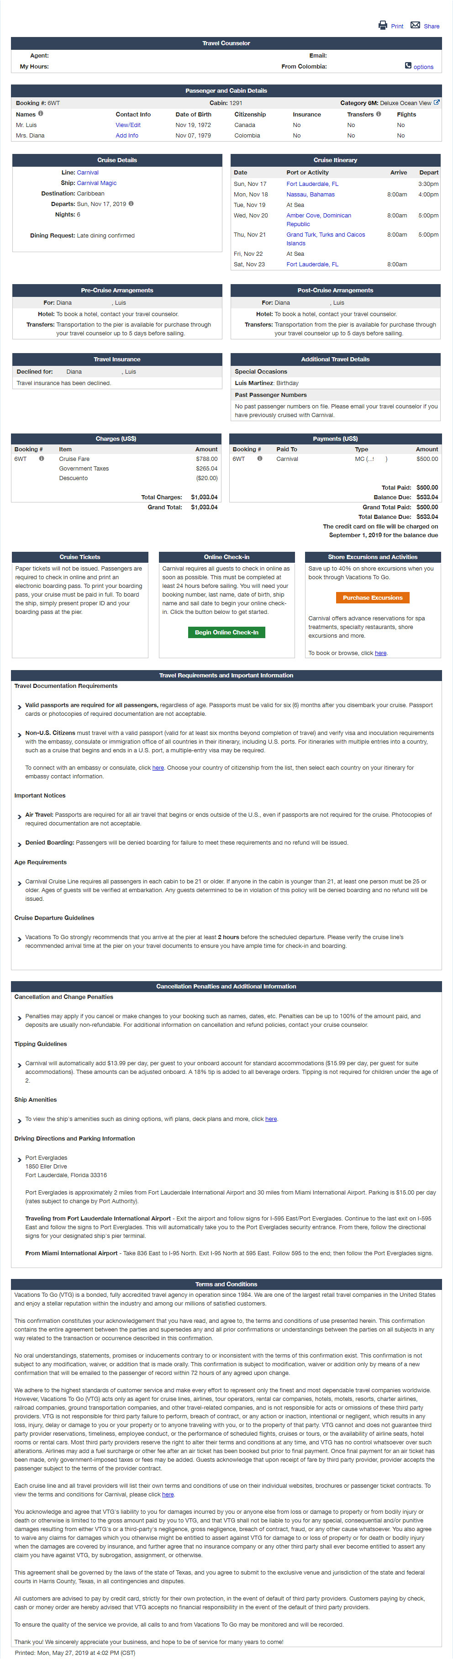







External links

The Backen must allow to manually input the taxes porcentages values to calculate the final prices







The information must change all reference of “ Vacations To Go” to “Cruceros On Sale”

Special atention must be paid when doing the scraping in the “More Cruise Deals” sections, the information consult metod may change according each cruiser line offer and type of user.

**LIST OF MODULES FOR CRUCEROSONSALE**

**BACK-END SUPER ADMINISTRATOR, TRAVEL AGENTS**

**Dashboard:** the dashboard must have home, graphic indicators to give information of our interest.

**Module to manage the header, footer logo, banner:** this module is to change the logo of the web page that is in front-end.

**Page module:** This module is to control all pages that contain text on the web, and also the texts that will go in the quotation template, and the purchase order.

**Language module:** this module will allow you to change the language from English to Spanish.

Module for Purchase Orders: This module is for viewing all service orders and payments made by the customer, and that you can see all purchase details, which also shows the status of that purchase. You should also have the option to download list of purchase orders with your payments and other data in Excel format.

**Module for customer payment report:** this module is to generate a report of all sales that have been made on the website, per day, / month / per year. You must have the option to download report in Excel format

**Module for customer list:** this module is for viewing all the lists of customers that are registered on the web. You must have the option to download the client list in Excel format.

**Module to create, view, edit, delete employees in backend:** this module is to create, view, edit, delete employees who will have access to the administration backend with their profile.

**Roles module:** this module is to create the roles and give permissions to the module that has the backend according to its profile, when permission is given to some module it can be visible in the backend of travel agents.

**Notification module:** this notification module must send an email to the administrators of the website notifying you that a quote has been requested, in order to be aware of the notifications sent to travel agents. This module also applies to travel agents, so they can know they have a quote to make.

In addition, these notifications should appear in the header with a bell icon to be in the administrator's view, and of the travel agent. This module must also send us a notification when a payment has been made.

You must also notify the customer, by mail that you have successfully registered, and that your account is active and that you can request the services of the site.

**Quotation tracking module:** this module is for the back-end super administrator to know what quotes the travel agent has attended, and if he has sent the quote to the clients.

In addition, this module must have the option where you can see what quotation our supplier sent you and which quotation was sent to the client.

**Email module:** this module is for reading, viewing, sending, responding to emails that all travel agents have sent to customers, such as the quote that has come from vacation to Go. This module must comply with all security so that it does not enter malicious mail or spam or filter it in the spam tab. In order to be deleted.

**Price module for cruises:** this module is to place the percentage of profit at the rates that is captured through vacation to GO scraping.

**Module list the newsletter clients:** this module is to see which customers have subscribed to our newsletter; This module must have the option of being able to download the client list in Excel format. The list must be able to be edited, new customers entered or deleted.

**Sales module:** this module is for the travel agent, so that they can process the request for quotation that has arrived between CRUCEROSONSALE and VACATIONTOGO so that there is a record of that quote that they entered from the CRUCEROSONSALE platform and to know in what state is. For example, if the travel agent has already processed that quote with our cruise provider and in what state it is: if it is pending to confirm a quote by our provider or if it has already been processed by our travel agents and if the quote has already been sent to client.

**Make a quotation module:** In this module the travel agent can see all the quotation requests that he has to process with the VACATIONTOGO provider, this module will have a special format for CRUCEROSONSALE, so that the quote arrives with our information and our logo to the client , you must also have an option for the agent to add additional services requested by the client. And you can add it to the quote that our provider processed before.